Paddock Setup Redesign
End-to-end solution proposal for setup, parsing, workspace creation, and live enrichment
Recommended direction: remove the confirmation form, treat the editor as the only recovery mechanism, replace user-facing format classification with internal schedule evidence, and redirect immediately to the course workspace where enrichment streams in live.
Prepared for  Paddock setup redesign | Date  2026-04-20 | Inputs reviewed  v2 flow diagram, redesign handoff

UX outcome  No retry loop. The student always lands in the same editor and then in the workspace. | Architecture outcome  formatHint becomes internal schedule evidence; week rows become the setup source of truth. | Delivery outcome  Ship deterministic v1 distribution, feature-flag the flow, and stream enrichment through SSE with polling fallback.

Primary recommendation
Keep the parser cascade and the cached plan. Move all confidence levels into one side-by-side editor, remove domain, professor name, and format hint from student-owned input, add firstClassDate when real dates are missing, and send the student directly to /paddock/[courseId] where enrichment becomes visible in place.

Executive summary
The existing three-tier parser cascade is already strong enough for most syllabi. The main failures are downstream: a brittle formatHint, setup fields that should not be user-owned, a finalize step that can still trigger rebuild logic, and a redirect to a dashboard state that cannot show meaningful progress while enrichment runs.
Decision area | Recommendation | Why it wins | Order
Confirmation step | Remove the classification form | The editor becomes the only recovery mechanism, which eliminates the retry loop and the trust hit from a separate correction screen. | v1
Format signal | Make format evidence server-only | Replace user-facing formatHint with scheduleEvidence plus confidence. The UI should describe what was found, not ask the student to classify the syllabus. | v1
Setup payload | Own only editable setup inputs | Accept courseTitle, termLabel, meetingDays, firstClassDate, and weeks[]. Drop domain, professorName, and formatHint from the client payload. | v1
Calendar synthesis | Add firstClassDate when anchors are missing | Meeting days alone are not enough for a fully topic-based syllabus. One temporal anchor makes schedule generation deterministic. | v1
Redirect target | Go straight to /paddock/[courseId] | The workspace is the first place where the week plan is useful and enrichment can accumulate in place. | v1
Streaming | Use SSE with polling fallback | SSE matches the upload mental model and gives immediate visibility, while polling covers disconnects without backend complexity. | v1
Topic distribution | Use deterministic rules first | Preserve anchors, spread remaining topics evenly, and defer heavier LLM weighting or grouping until the flow is stable. | v1.1

What should remain from the current branch
Keep the upload SSE progress events, the parsed plan cache in paddock_setup_drafts.parsed_plan_json, the enrichment status threading, the multi-course dashboard regression fix, and the interim confirm progress screen until the new editor path is behind a feature flag.

Root-cause diagnosis
Problem | Root cause | User impact
Frozen confirm | The user is still in the wrong surface when creation starts | The confirm screen can only wait; it cannot help the student verify or improve the plan.
Wrong fields | domain, professorName, and formatHint are user-editable | These fields can corrupt canonical matching, deduplication, and trust.
Format mistakes | detectFormatHint() counts raw date or number lines | Administrative dates and numbered policy sections are misclassified as schedule structure.
Plan rebuild risk | Meeting-day corrections can regenerate without a clear row contract | The system can mutate content that the student thinks is fixed.
Dead post-create state | The dashboard cannot express 70-200 seconds of enrichment meaningfully | The student sees a pulsing wait rather than a usable workspace.

Target end-to-end flow
The target experience is one continuous path: upload, parse, edit, create, and watch the course fill in live. Confidence changes how much is prefilled, not which screen the student sees.
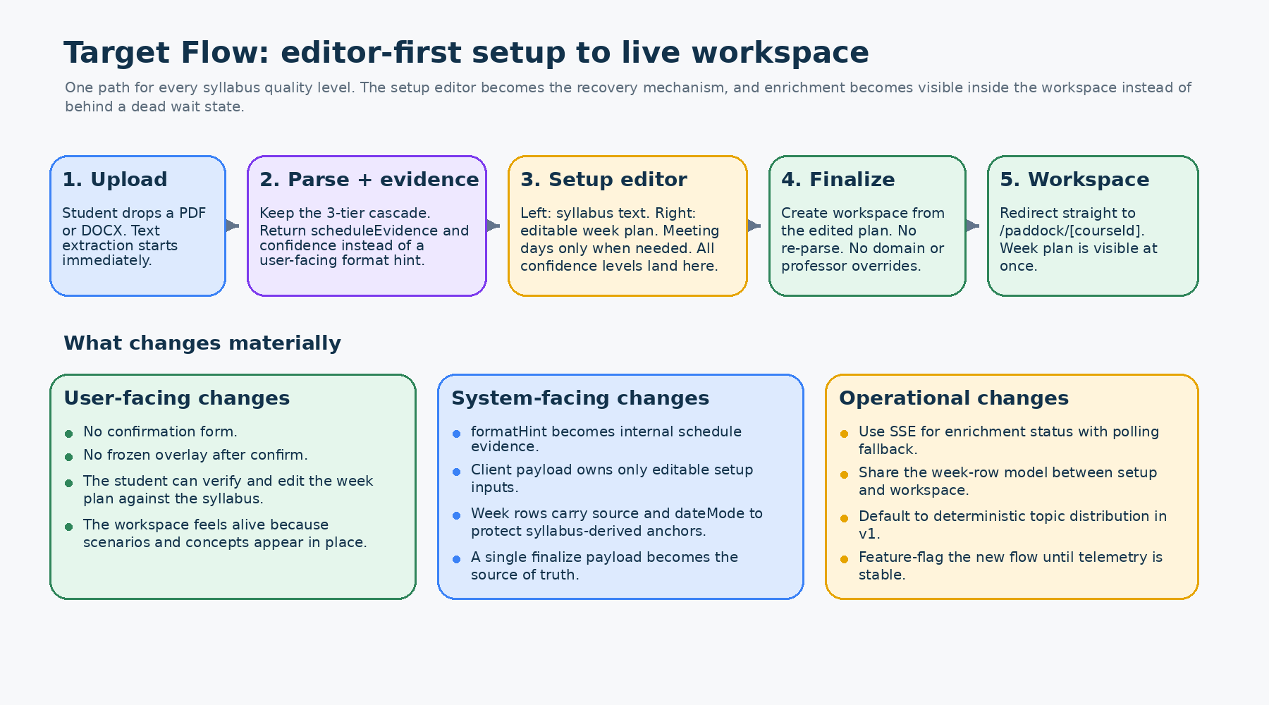
Proposed end-to-end flow: editor-first setup followed by a live workspace.
User journey
• The student uploads a syllabus and sees progress during extraction and parsing.
• The server returns a parsed draft plus schedule evidence and a confidence level.
• The student always lands in the same side-by-side editor with syllabus text on the left and the week plan on the right.
• Finalize creates the workspace from the edited plan without asking the student for domain, professor name, or a format correction.
• The student lands in the new course immediately and watches concepts, domain, scenarios, and ready-state signals appear in place.
Design principle
The editor is not a fallback branch; it is the default and only setup surface. That keeps the flow trustworthy for high-confidence parses and recoverable for low-confidence parses.

Editor-first setup experience
Every confidence level lands in the same editor. High-confidence drafts feel almost complete, medium-confidence drafts ask for the minimum missing calendar information, and low-confidence drafts can start from a blank 14-week plan without leaving the surface.
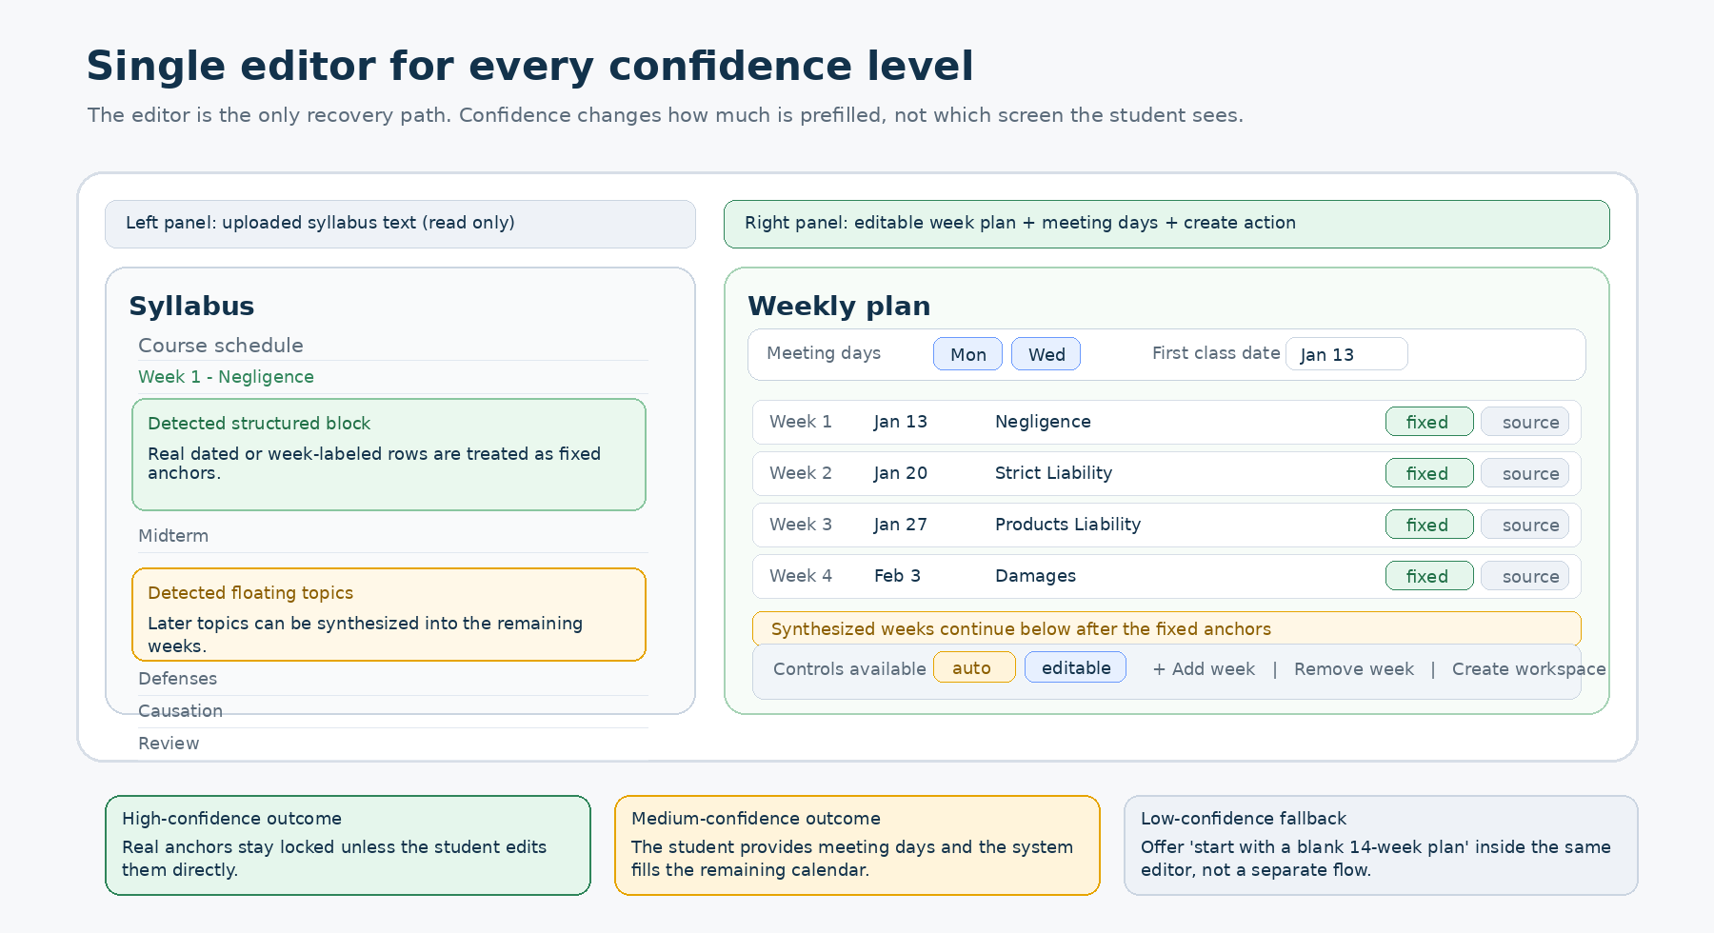
Single-editor setup: syllabus reference on the left, editable week plan on the right.
Confidence | Trigger | Editor behavior | Student ask
High | 4+ genuine date-topic pairs or strong week labels | Real anchors are prefilled and treated as fixed unless the student edits them directly. | Usually none
Medium | Topic structure exists but dates are partial or absent | Topics are prefilled, dateMode=auto rows are synthesized, and the calendar fills after meetingDays and firstClassDate are provided. | meetingDays and firstClassDate when needed
Low | Few usable milestones or ambiguous structure | Show the best attempt plus a clear 'start with a blank 14-week plan' action inside the same editor. | Optional heavy editing

Decisions for unresolved UX questions
Question | Recommendation | Reason
Semester length | Do not ask explicitly in v1 | Default to 14 weeks, use real anchors when present, and let the student add or remove rows.
Manual setup | Do not create a separate mode yet | A blank 14-week option inside the editor is enough for the first release.
Shared components | Share the core week-row editor model only | Setup and workspace wrappers have different responsibilities and should not be the same page component.

Parsing, evidence, and detection
The parser cascade stays. What changes is the contract around it: the system should return schedule evidence and confidence to drive the editor, not a user-facing format classification dropdown.
Internal schedule evidence object
type ScheduleEvidence = {
scheduleStructure: 'dated' | 'numbered' | 'topic_based' | 'hybrid' | 'unclear';
confidence: 'high' | 'medium' | 'low';
dateTopicPairs: number;
weekLabels: number;
topicalHeadings: number;
adminDateLines: number;
structuredBoundaryIndex?: number;
};

Detection changes
Area | Current rule | Proposed rule | Outcome
Dated detection | Count raw date lines; threshold 5 | Count only genuine date-topic pairs after filtering administrative lines; threshold 4 | Short real schedules are detected, while scattered due dates stop misclassifying the syllabus.
Numbered detection | Count any numbered lines | Filter out non-topic headers such as grading, attendance, materials, and prerequisites before counting | Policy outlines stop looking like weekly structure.
User-facing signal | Expose formatHint as a correction field | Expose plain-language evidence such as 'We mapped 11 class meetings' or 'Add meeting days to place these topics on the calendar' | The UI stays truthful even when confidence is medium.
Partial temporal handling | No explicit evidence boundary | Return structuredBoundaryIndex and preserve the structured portion as fixed | The editor can mark 'from syllabus' versus 'synthesized' honestly.

Why formatHint should disappear from the UI
The student does not care whether the system labels the syllabus 'dated' or 'topic-based'. The student cares whether the mapped plan looks right. Evidence-based copy preserves trust while still giving the system the structure signal it needs.

Week model and calendar synthesis
The setup editor and the finalize endpoint need a shared row model that distinguishes syllabus-derived anchors from synthesized dates. That is the key to safe regeneration when meeting days change.
Recommended row contract
type WeekRow = {
id: string;
weekIndex: number;
title: string;
date: string | null;
source: 'syllabus' | 'synthesized' | 'manual';
dateMode: 'fixed' | 'auto';
};

type SetupFinalizePayload = {
draftId: string;
courseTitle?: string;
termLabel?: string;
meetingDays?: string[];
firstClassDate?: string;
weeks: WeekRow[];
};

Field | Purpose | Why it matters
source | Tracks whether a row came from the syllabus, was synthesized, or was added manually. | The editor can show honest provenance and the backend can treat anchored rows differently.
dateMode | fixed rows stay stable unless the student edits them; auto rows can be recalculated. | Meeting-day changes do not rewrite syllabus-derived anchors.
firstClassDate | Required only when the syllabus lacks real calendar anchors. | Meeting days alone are insufficient to synthesize a reliable calendar.

Deterministic v1 distribution
totalMeetings = semesterWeeks * meetingsPerWeek

preserve all fixed rows
remainingSlots = totalMeetings - fixedRows.length

if remainingTopics roughly match remainingSlots:
spread topics 1:1 and reserve leftover slots for review
else if remainingTopics < remainingSlots:
spread topics evenly and assign extra slots to heavier topics using simple heuristics
else:
group adjacent related topics deterministically and let the editor remain the safety net

Scope boundary for v1
Do not make the first release depend heavily on an LLM for topic weighting or grouping. Use deterministic spreading and lightweight heuristics first, then add LLM assistance later for medium-confidence topic-based drafts.

Partially temporal syllabi
For hybrid syllabi, preserve the structured part exactly as extracted, compute the remaining semester slots, and synthesize only the floating topics after the boundary. The editor should visually mark this boundary so the student knows which rows came directly from the syllabus and which rows were inferred.
Workspace creation and live enrichment
After finalize, the student should never return to a holding dashboard. The new course workspace is the primary destination because it already contains the week plan and can accumulate enrichment in place.
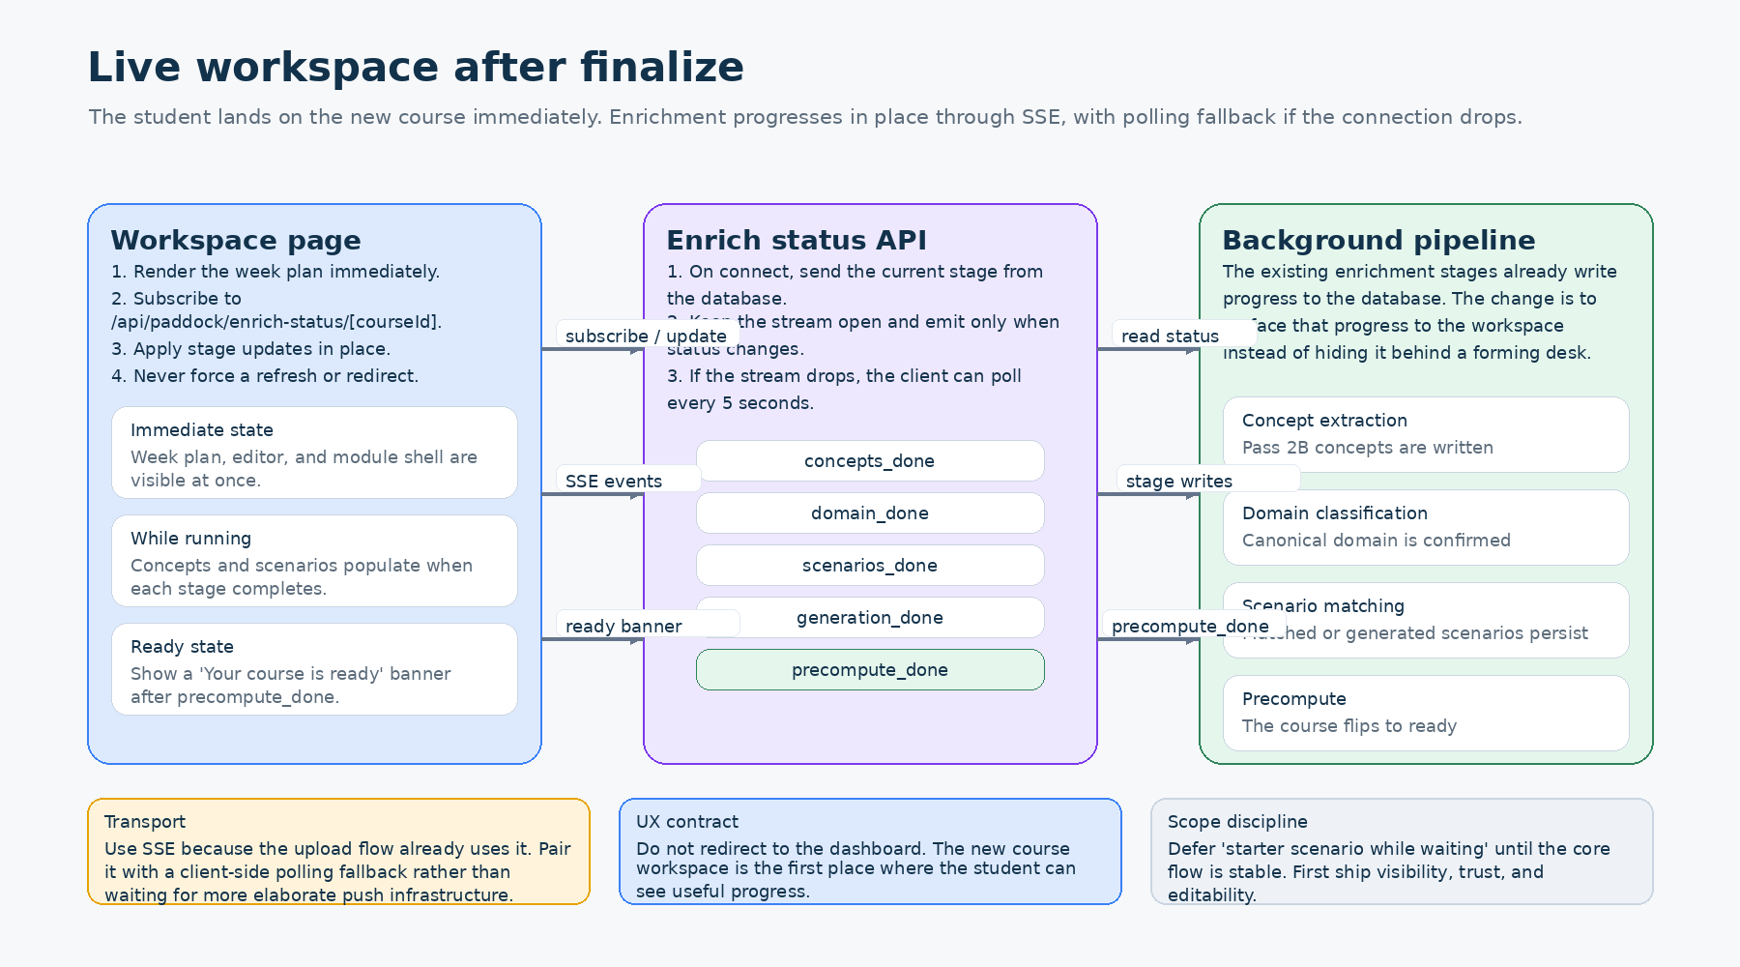
The workspace subscribes to enrichment progress and updates in place.
Event | UI effect | Why it matters
concepts_done | Concepts and module-level learning structures appear in the workspace. | First meaningful content improvement after the initial plan.
domain_done | The system shows the confirmed domain internally for matching and generation. | No student override is needed.
scenarios_done | Matched or generated scenarios populate the course experience. | The waiting period becomes visibly productive.
generation_done | Longer-tail generation assets are attached when needed. | Novel domains continue to improve without blocking initial use.
precompute_done | Show 'Your course is ready' and flip remaining ready-state UI. | The student gets a clear end state without refreshing.

Transport recommendation
Use SSE for the primary transport because the upload flow already uses it and the mental model fits. Implement a polling fallback in the client so a dropped stream degrades gracefully instead of leaving the page stale.
Non-goals for the first release
Do not wait for pg NOTIFY, a perfect push infrastructure, or a starter scenario while the course forms. The first release should solve trust, visibility, and editability.

Implementation plan
The cleanest delivery path is contract-first. Update the parser evidence and finalize payload first, then build the editor, then switch the post-create destination and streaming behavior behind a feature flag.
Phase | Major work | Done when
Phase 1 - contracts | Replace user-facing formatHint with scheduleEvidence; update finalize schema; add WeekRow and firstClassDate. | New payloads compile end to end without the old fields.
Phase 2 - setup UI | Replace CourseClassificationConfirm with SyllabusEditor and WeekPlanEditor; wire confidence messaging and blank-plan fallback. | A student can create a workspace without touching the old confirm form.
Phase 3 - workspace streaming | Add /api/paddock/enrich-status/[courseId]; subscribe from [courseId]/+page.svelte; show live enrichment states. | The course workspace visibly improves after creation.
Phase 4 - hardening | Add telemetry, feature flag, rollback path, and regression tests for fixed vs auto rows. | The new flow is safe to expand.

Area | Key changes | Files
Frontend | Replace confirm phase in PaddockQuickSetup.svelte; add SyllabusEditor.svelte and WeekPlanEditor.svelte; subscribe to live status from [courseId]/+page.svelte. | apps/web-svelte/src/lib/components/paddock/*  apps/web-svelte/src/routes/paddock/[courseId]/+page.svelte
Backend | Fix detectFormatHint() behavior or replace it with evidence generation; update setup/confirm endpoint; add enrich-status SSE endpoint; add topic-distribution.ts. | apps/web-svelte/src/lib/server/paddock/syllabus-metadata.ts  apps/web-svelte/src/routes/api/paddock/setup/confirm/+server.ts  apps/web-svelte/src/routes/api/paddock/enrich-status/[courseId]/+server.ts
Shared model | Define WeekRow, SetupFinalizePayload, and evidence types so setup and workspace agree on row ownership. | routes/paddock/syllabus-api.ts or shared type module

Rollback path
Keep the old confirmation component behind a feature flag until telemetry shows that the new editor path is stable. Delete the old component only after the new finalize payload, redirect, and stream behavior are proven.

Acceptance criteria and telemetry
Acceptance check | Expected behavior
Setup contract | The client can no longer submit domain, professorName, or formatHint to the finalize endpoint.
Plan stability | Fixed rows never move when meetingDays changes unless the student edits those rows directly.
Topic-based fallback | A syllabus with no real anchors can be finalized with meetingDays, firstClassDate, and an editable set of rows.
Redirect | After creation, the user lands on /paddock/[courseId], not the dashboard.
Visibility | Enrichment stages become visible in the workspace within one status cycle of the database update.
Recovery | Low-confidence drafts can start from a blank 14-week plan inside the same editor.

Metric | Why instrument it
setup_editor_shown | How often the student reaches the editor by confidence band
setup_editor_edits_count | How much manual correction is needed before finalize
finalize_to_workspace_ms | Whether creation feels immediate
enrich_stage_duration_ms | Where the background pipeline spends time
sse_disconnect_rate | How often polling fallback is needed
fixed_row_mutation_count | Regression detector for anchor stability

Resolved open questions
Question | Answer | Rationale
Ask for semester length? | No | Default to 14 weeks unless real anchors imply otherwise. Let the student add or remove rows.
Build separate manual mode? | No | Keep one editor and provide a blank-plan action inside it.
Share the full page component? | No | Share the row editor model and validation, not the whole page wrapper.
SSE or polling? | Both | SSE first for UX; polling fallback for resilience.
Starter scenario while waiting? | Later | Not needed for the first release.

Bottom line
Make setup editor-first, evidence-driven, and workspace-first. Demote format detection from a user-facing decision to an internal signal, and let the edited week plan become the source of truth that creation and enrichment build on.

Appendix: referenced inputs
Reviewed source materials: paddock-setup-flow-v2.html and paddock-setup-redesign-handoff.md.

