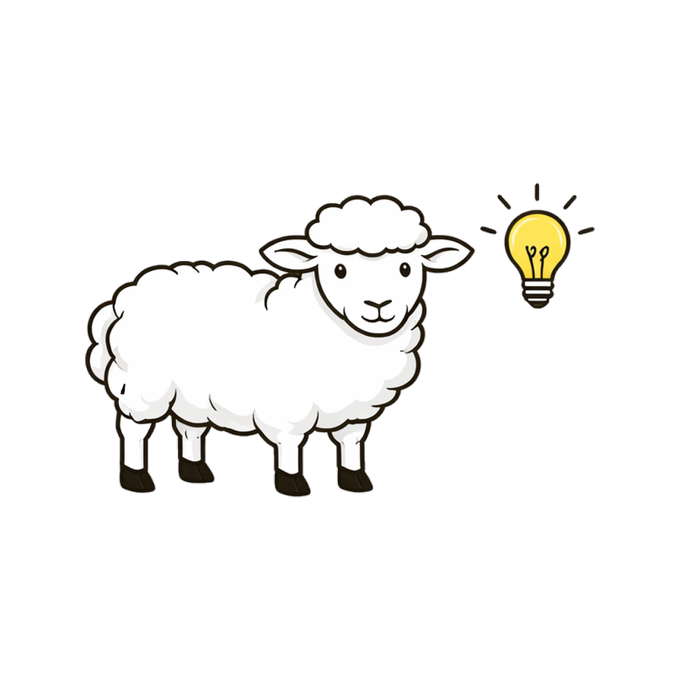
SHEP MEE Prep
Bar Prep by SHEP · Durham Lex, Inc.
shepbarprep.com
Scan to start free

Exclusively for GW Law Students

MEE Prep that helps you find
the issues you're missing.
Write timed practice essays, receive structured scoring across four rubric dimensions, and repair weak rule statements with focused recall drills — all before exam day.

72
Original essays
558
⁺
Validated rules
8
MEE subjects

How It Works
01 / WRITE
The prompt
Pick a timed prompt or upload your own. Write inside SHEP under exam conditions.
02 / SCORE
The feedback
Get scored on issue spotting, rule statements, application, organization, and conclusion.
03 / REPAIR
The drills
Missed rules become focused recall reps. Fix weak spots before the next essay.

What's Included
Timed essay practice
— 30-minute prompts that mirror exam conditions
Structured scoring
— every essay graded on four rubric dimensions
Upload your own prompts
— bring questions from any source for grading
558+ rule recall drills
— active reps built from validated black letter law

GW Law Exclusive Discount
$40 off
the SHEP Founding Pack
$129
$89
· one-time, July 2026 access
Use code
GWLAW40

Try one essay free at shepbarprep.com
No sign-up required.
Bar Prep by SHEP

Built by a law graduate & a Fortune 10 senior engineer.

Independent study tool, not affiliated with NCBE.

