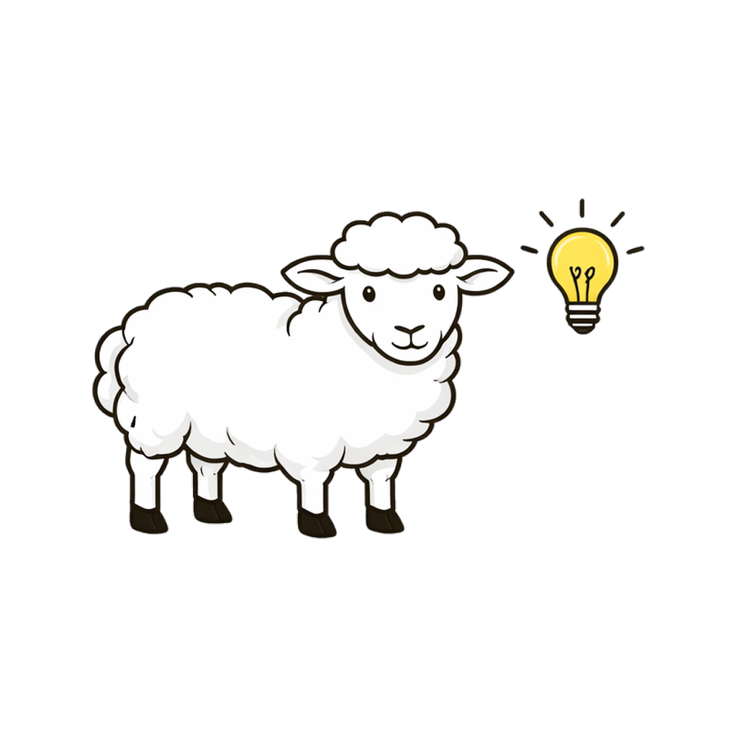
SHEP MEE Prep
shepbarprep.com
Scan to write a free essay

For Students of GW Law

MEE Prep that helps you find
the issues you're missing.

Essay Prompt
Scoring Rubric
Contracts · Q. III
Owner entered into a written contract with Builder for the construction of a custom home.
Six months in, Builder encountered unexpected rock formations requiring expensive blasting...
Mutual Mistake Analysis
Issue. Whether Builder has grounds to recover the additional $50,000.
Rule. Under Restatement (Second) §152, a mutual mistake as to a basic assumption renders the contract

Band 5
Above average
+2

ISSUES
RULES
APPLY
ORG
CONCL

Write a practice essay inside SHEP. Receive a structured score across issue spotting, rule statements, application, and organization. Upload prompts from your own course or work from our library of original questions modeled on the NCBE outlines. Repair weak rule statements with focused recall drills — before exam day, not after.

Write.

Score.

Repair.
72
original essays ·
558+
validated rules ·
8
MEE subjects

Exclusively for GW Law Students
GWLAW40
$40 off
the founding pack
$129
→
$89
one-time, July 2026 access

Try one essay
free
at shepbarprep.com
No sign-up required.
Bar Prep by SHEP
Built by a law graduate & a Fortune 10 senior engineer.
Independent study tool, not affiliated with NCBE.

